Dylan

Use the tools and resources from class and the sample function code below to help complete this assignment.

Sample Function 1: Positioning the Pen

The following function positions the turtle pen without drawing anything.   
The parameter “xPos” is the amount left or right to move the pen

The parameter “yPos” is the amount up or down to move the pen

*def movePen(xPos, yPos) :*

*myPen.up()*

*myPen.forward(xPos)*

*myPen.right(90)*

*myPen.forward(yPos)*

*myPen.left(90)*

*myPen.down()*

Sample Function 2: Drawing a Blue Box

The following function draws a blue box with the top left corner at the current pen position. The parameter “size” is the size of the box.

*def blueBox(valSize) :*

*myPen.down()*

*myPen.color( "blue" )*

*myPen.forward(valSize)*

*myPen.right(90)*

*myPen.forward(valSize)*

*myPen.right(90)*

*myPen.forward(valSize)*

*myPen.right(90)*

*myPen.forward(valSize)*

*myPen.up()*

Write your answers to the questions below in hard copy format. (i.e. pen or pencil)

1. Describe the shape produced by the following code:

*movePen(0,0)*

*blueBox(40)*

*movePen(20,60)*

*blueBox(40)*

*movePen(80,0)*

*blueBox(40)*

*movePen(-100, -60)*

*blueBox(40)*

This code produced four small squares on the D-Pad and all of the squares had an outline which is blue. The four blue squares are spaced out where the center of the squares is a blank space. The first blue square was the under the center. The second blue square was to the right of the center. The third blue square was to the left of the center. The last blue square was above the center.

1. Modify the blue box function to produce the following shape:

**Question 2 Code**

import turtle

myPen = turtle.Turtle()

def Box(valSize) :

myPen.down()

myPen.forward(valSize)

myPen.right(90)

myPen.forward(valSize)

myPen.right(90)

myPen.forward(valSize)

myPen.right(90)

myPen.forward(valSize)

myPen.begin_fill()

myPen.right(135)

myPen.forward(valSize * 1.4)

myPen.right(135)

myPen.forward(valSize)

myPen.end_fill()

myPen.up()

Box(60)

1. Write a program using your function(s) to produce a pattern similar to the following:

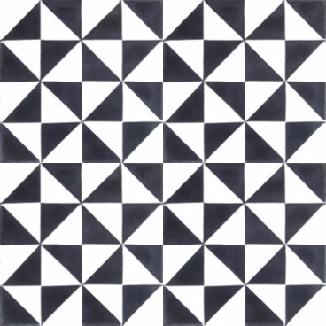

**Question 3 Code**

import turtle

myPen = turtle.Turtle()

#Functions

#------------------------------

def Box_Right() :

myPen.down()

myPen.begin_fill()

myPen.right(180)

myPen.forward(40)

myPen.right(135)

myPen.forward(40 * 1.4)

myPen.end_fill()

myPen.up()

myPen.right(45)

myPen.forward(40)

def Box_topRight():

myPen.down()

myPen.begin_fill()

myPen.right(90)

myPen.forward(40)

myPen.right(135)

myPen.forward(40 * 1.4)

myPen.end_fill()

myPen.up()

myPen.right(135)

myPen.forward(80)

myPen.right(90)

myPen.forward(40)

myPen.left(90)

def Box_bottomLeft() :

myPen.down()

myPen.begin_fill()

myPen.forward(40)

myPen.left(90)

myPen.forward(40)

myPen.left(135)

myPen.forward(40*1.4)

myPen.left(135)

myPen.forward(40)

myPen.end_fill()

myPen.up()

myPen.left(90)

myPen.forward(40)

def Box_left() :

myPen.down()

myPen.begin_fill()

myPen.left(90)

myPen.forward(40)

myPen.right(90)

myPen.forward(40)

myPen.right(135)

myPen.forward(40 * 1.4)

myPen.end_fill()

myPen.up()

myPen.left(45)

myPen.left(90)

myPen.forward(39)

myPen.left(90)

myPen.forward(40)

myPen.left(180)

#-------------------------------

# The code below makes the image.

for i in range(4):

myPen.delay(1)

for i in range(4):

Box_Right()

Box_topRight()

myPen.left(90)

myPen.forward(2)

myPen.left(90)

myPen.forward(360)

myPen.left(90)

for i in range(4):

Box_bottomLeft()

Box_left()

myPen.forward(40)

myPen.right(90)

myPen.forward(280)

myPen.left(90)

myPen.forward(40)

myPen.left(90)

#This is the end of the code.